Chapter 7, Solution 49.

For 0 < t < 1, 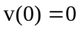, 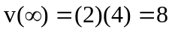
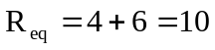, 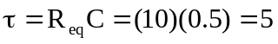
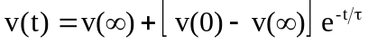
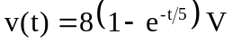

For t > 1, 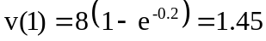, 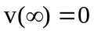
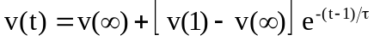
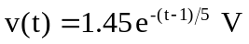

Thus,
